BrokerLink™
Workday Implementation – Data Lakehouse Integration
Solution Proposal Document
Version 0.1


Name
Solution Architect, Genpact, Inc.
Date



Confidentiality 4

Document Revision History 5

1. Introduction 6

1.1 Opportunity/Goal 6

1.2 In Scope 7

1.3 Stakeholder / User Groups 7

1.4 Anticipated Benefits 8

1.5 Dependencies 8

1.6 Risks 12

1.7 Assumptions 13

2. Business Requirements 13

2.1 Reporting Requirements 13

2.2 Data Lakehouse Environment Access 14

3. Proposed Solution Approach 15

3.1 Requirements 15

3.2 Future State Design – Data Models 15

3.2.1 Workday 15

3.2.1.1 Bronze 15

3.2.1.2 Silver 15

3.2.1.3 Gold 17

3.2.1.4 Lineage Diagram 18

3.2.1.5 End to end Pipeline Diagram 18

3.2.1.6 Workday Source to Target Mapping 19

3.2.1.7 Deployment Runbook 19

3.2.1.8 Notebook Pseudocode summary 19

3.2.1.9 Workday Lakeflow Connector Steps 22

4. Testing Considerations 24

4.1 Testing Objectives 25

4.2 Scope of Testing: 25

4.3 Testing Approach and Methodology: 26

4.4 Testing Techniques and Tools: 26

4.5 Risks and Mitigation Strategies: 27

4.6 Exit Criteria: 27

5. Expected Project Results 28

5.1 Measures of Success 28

5.1.1 Data Quality & Integrity Measures 28

5.1.2 Operational Reliability Measures 29

6. Approvals 29

6.1 Solution Document Sign-Off 29

Appendix A: Impact Areas 30

Appendix B: References 31

Contents

Confidentiality
The information contained in this document is the proprietary and exclusive property of Canada BrokerLink Inc. except as otherwise indicated. No part of this document, in whole or in part, may be reproduced, stored, transmitted, shared, or used for design purposes.
This document may contain information of a sensitive nature. This information should not be given to persons other than those who are involved in the <Project Name> project or who will become involved during the lifecycle.

Document Revision History

Date | Version | Author | Description of Changes
2025-12-08 | 0.1 | Genpact Team | Initial Draft

Introduction

This document provides an overview of the implementation approach for integrating Workday HR data into BrokerLink’s Databricks Data Lakehouse using Databricks Lakeflow, Delta Live Tables (DLT), and Unity Catalog.
Workday will serve as the new enterprise HR system replacing UKG Pro by the end of 2025. Workday provides foundational employee datasets including Job, Personal, License, Status, and Historical changes through secured RaaS (Report-as-a-Service) endpoints.
These Workday datasets, when ingested and transformed within Databricks, will supply the trusted HR data required by downstream reporting systems such as SSRS and PowerBI. This ensures operational continuity and provides accurate insights into workforce structure, employee movement, compliance, and organizational reporting.
The redesigned Lakehouse solution will modernize the ingestion pipelines, implement effective-dated logic, handle historical changes, and enhance monitoring, quality rules, and observability across all HR datasets.

Opportunity/Goal

The opportunity/goal of the solution | Enable automated and reliable ingestion of Workday HR data (Job, Personal, Status, License & historical datasets) into the Databricks Data Lakehouse using Lakeflow Connect & Delta Live Tables, ensuring standardized transformations, effective-dated logic (SCD2), and high-quality HR datasets for SSRS and PowerBI reporting.
Affects | Business intelligence, HR operations, finance reporting, and analytics teams across BrokerLink who depend on accurate, timely, and historical HR data.
The impact of which is | - A single source of truth for all Workday-based HR reporting  - Improved data quality and consistency across Bronze, Silver, and Gold layers  - Automated ingestion, transformation, and soft-delete handling  - Reliable historical tracking through effective-dated (SCD2) processing  - Simplified and scalable data modeling aligned with Databricks best practices  - Reduced manual intervention through automated daily refresh and historical processing  Operational work is not hindered by:  - Missing or inaccurate employee data  - Slow or inconsistent ingestion pipelines  - Schema drift or unexpected mapping issues
Which will provide value / benefits to the company of | - Ensuring accurate HR data for payroll, compliance, workforce planning, and leadership dashboards  - Improved operational efficiencies and decreased manual validation  - Faster and more reliable decision-making from standardized, trusted employee datasets  - End-to-end observability through enhanced logging, lineage, and DLT expectations  - Future-ready scalable architecture supporting additional HR analytics initiatives

In Scope
The following items are included in the scope of this design:
- Ingestion five Workday reports (RaaS):
  - Employee Job Daily
  - Employee Personal Daily
  - Employee License Daily
  - Employee Status Historical
  - Employee Job Historical
- Use of Lakeflow Connect pipelines to ingest raw Workday JSON/XML into Bronze.
- Bronze layer ingestion model updates.
- Silver and Gold model refinements.
- Re-engineering ETL pipelines with Databricks native capabilities
- Use of DLT to define all silver dimension tables including:
  - dim_employee_lob_function
  - dim_employee_company
  - dim_employee_business_unit
  - dim_employee_cost_center
  - dim_employee_job_code
  - dim_employee_pay_frequency
  - dim_employee_job_location
  - dim_commission_plan
  - dim_commission_draw
  - dim_employee_status
  - dim_employee_hierarchy
  - dim_employee_personal_info
  - dim_employee

- Use of DLT to define all Gold layer dimensions / fact tables including:
  - dim_employee
  - daily_employee_fact
  - dim_hierarchy
  - dim_employee_current
  - dim_combined(UKG_Workday)

Stakeholder / User Groups
Stakeholder / User | Description of Stakeholder / User Group and Responsibilities
Business Teams | - Provide and sign off on data requirements.  - UAT test of silver and gold layer data  - UAT test of Power BI reporting.
Genpact Dev Team | Responsible for the creation and delivery of technical development & project artifacts.
BL Dev Team | Responsible for Code Review in SIT / UAT
Solution Architect | Responsible for end-to-end solution architecture designing and implanting best practices across all technical stacks,
Project Manager | Responsible for providing the project deliverables in timely manner.
Analytical Team | Responsible for providing Power BI KPIs and requirements.
Admin / IT Team | Responsible for handling all hardware. Software and access related requests.

Anticipated Benefits
- Seamless transition from UKG to Workday as enterprise HR source.
- Improved data accuracy through properly modeled effective dates, org structures, and historical tracking.
- Modernized, resilient ingestion pipelines using Lakeflow + Databricks native tools.
- Reduced manual work through automated historical refresh mechanisms.
- Improved reliability and observability through enhanced monitoring.
- Consistent PowerBI dashboards with maintained reporting continuity for end users.
- Future scalability for additional HR analytics initiatives.

Dependencies
These are modules, packages, and helper functions for the scripts to relies on:
Python & Spark Libraries
The Workday ingestion and transformation pipelines rely on Databricks-native capabilities supplemented by standard PySpark and Python modules:
Core Python Modules
- time: Used for runtime utilities and timestamp generation
- logging: For structured logging during transformation execution
Configuration & Utility Modules
- argparse, yaml: Used in supporting modules for parsing configs (where applicable)
- pyspark.sql modules:
  - SparkSession
  - Window
  - functions as F
  - StructType, StructField, StringType, and other schema types
These libraries support the Workday DLT pipelines for SCD2 logic, column transformations, schema handling, and incremental processing.
Custom Helper Modules (Project-Specific Utilities)
The Workday pipelines use shared helper utilities to standardize metadata, logging, and transformation behavior.
Referenced as:
from utilsh.utility import (
log_message,
new_process_id,
add_additional_fields,
set_default_values,
clean_col,
apply_scd2,
get_latest_record
)
Key Helper Functions Include:
Helper Function | Purpose
new_process_id() | Generates unique process IDs for traceability across runs
log_message() | Standardized structured logging for INFO/ERROR events
set_default_values() | Ensures missing or null fields receive consistent default values
clean_col() | Cleans column values (trimming, formatting, normalization)
add_additional_fields() | Appends metadata fields such as process_id, entity_name, load timestamps
apply_scd2() | Applies SCD Type-2 logic for effective-dated dimensional modeling
get_latest_record() | Returns latest Workday record by effective date for deduplication
These utilities ensure uniformity across all dimension pipelines (Employee, Job, Pay Frequency, Cost Center, Location, Commission Plan, etc.).
Databricks Lakehouse Services and Runtime Components
Because this program uses upgraded Databricks-native tooling, ingestion and transformation depend on:
Lakeflow Connect (Ingestion Layer)
- Handles Workday RaaS API authentication
- Manages incremental vs. full loads
- Auto-schedules ingestion workflows
- Writes raw Workday data into the Bronze layer
- Eliminates the need for custom REST connectors in Python
Delta Live Tables (DLT – Silver & Gold Transformations)
- Supports declarative SQL/Python transformations
- Implements expectations (data quality rules)
- Manages schema evolution automatically
- Provides lineage and observability for the HR data model
Databricks Notebooks (Modular Logic Layer)
- Implements reusable logic for SCD2, metadata management, effective-dated transformations
- Allows parameterized execution and configuration-driven controls
Custom Helper Module
- from bldbhelpers import *
    - setup_logging()
    - standard_arg_parser()
    - generate_process_id()
    - set_spark_context()
    - start_pipeline_log(), append_pipeline_log(), commit_pipeline_log()
    - add_default_metadata()S
    - execute_delta_overwrite(), execute_merge()

Secrets & Environment Configuration
Workday RaaS access requires secure, environment-specific secret handling:
Databricks Secrets
Stored and accessed via Unity Catalog–backed secret scopes:
Connection details are created at UC level as we have one hive-metastore and connection links will be available to workspaces. URL for each environment to be different.
Connection string were created by BL team.

Environment Arguments
Pipeline execution must resolve environment context properly, e.g.:
LOCAL, DEV, SIT, UAT, PROD
Environment determines:
- Catalog and schema routing (bronze/silver/gold)
- Secret scope selection
- Control table locations
- Logging and monitoring configurations
- Execution cluster/runtime behavior
External API Dependencies
- Status History (174) : https://wd3-impl-services1.workday.com/ccx/service/customreport2/intactfc1/ISU+INT+0174+Databricks+…
- Job History (175) : https://wd3-impl-services1.workday.com/ccx/service/customreport2/intactfc1/ISU+INT+0175+Databricks+…
- License Report (176) : https://wd3-impl-services1.workday.com/ccx/service/customreport2/intactfc1/ISU+INT+0176+Databricks+…
- Employee Personal File (177) : https://wd3-impl-services1.workday.com/ccx/service/customreport2/intactfc1/ISU+INT+0177+Databricks+…
- Employee Job File (178) : https://wd3-impl-services1.workday.com/ccx/service/customreport2/intactfc1/ISU+INT+0178+Databricks+…

- The API must be reachable and return to the valid JSON.
- The API key must be active and authorized.

Risks
No risks have been identified as of now.
The following risks have been identified for the Workday-to-Databricks integration project:
Risk | Impact | Mitigation
Delays in Workday RaaS report configuration or field mapping | Impacts development timelines and downstream testing | Early coordination with IFC HRMS team; iterative validation of RaaS extracts
Incomplete or inconsistent Workday data compared to UKG historical structures | Potential reporting inaccuracies or missing attributes | Conduct data profiling early; implement robust data quality checks in Bronze/Silver layers
Schema or field changes in Workday tenant during testing cycles | Pipeline failures or invalid transformations | Enable schema evolution where appropriate; maintain version-controlled mapping documentation
Differences between Workday and UKG business logic | Misalignment in downstream datasets and PowerBI visuals | Treat Workday as the new source of truth; adjust models without expecting one-to-one parity with UKG
API throttling or connectivity issues with Workday RaaS endpoints | Failed or partial ingestion, impacting daily refresh SLAs | Configure retries, monitoring, and Lakeflow Connect throttling controls
Ineffective exception handling or limited observability | Data outages or silent failures | Strengthen logging, alerts, and automated pipeline health checks

Assumptions
- Workday RaaS endpoints required for ingestion will be available, stable, and authenticated through IFC’s approved method (OAuth / API Key / WD Credentials).
- Workday RaaS reports will return consistent schemas for daily and historical extracts (or controlled schema evolution will be enabled).
- Lakeflow Connect and DLT pipelines will be used for ingestion and transformation, supporting incremental and full loads.
- Ingestion pipelines will remain idempotent — rerunning the same extraction or DLT pipeline will not corrupt or duplicate data.
- Effective-dated logic supplied by Workday will serve as the authoritative timeline for employee attributes; UKG timelines will not be used for regression comparison.
- Silver- and Gold-layer merge logic will correctly handle inserts, updates, and soft deletes across SCD Type 2 models.
- All code will follow standard modular notebook patterns and reusable configuration-driven logic across environments (DEV, QA/UAT, PROD).
- Required mapping files (e.g., Visual Lease location mapping) will be provided and refreshed as scheduled.
- Databricks Unity Catalog, schemas, and access controls will be fully provisioned prior to development and testing.

Business Requirements

Reporting Requirements

The Workday-to-Databricks integration must ensure continuity, accuracy, and reliability across all HR and cross-functional reporting domains. As Workday becomes the new system of record for employee data, downstream Power BI and SSRS reports must continue to function without disruption, while benefiting from improved data structures, effective-dated logic, and organizational alignment.

Current Power BI Reporting Considerations
Most Gold-layer fact tables—such as Policy, Google Ads, Quotes, Sales, and Claims—use employee attributes indirectly through the Employee Dimension. They do not consume the new Workday-specific fields (e.g., business unit, LOB/function, cost center).
Since the Workday integration only updates a small set of attributes in the Employee Dimension and does not change fact table structures, no existing Power BI reports are expected to be impacted.
This has been reviewed and agreed upon by both the BL Analytics team and the ETL Engineering team.
Future Reporting Impacts Will Be Managed Post–Go-Live:
Any future changes affecting:
• Gold-layer fact tables
• Workday-driven attribute updates
• Business rule modifications
• Additional Power BI reporting requirements
…will be assessed and delivered through the standard Engineering PoD/Sprint cycle after December 19, 2025.
This approach prevents delays to the Workday go-live and ensures that any downstream refinements follow normal governance, prioritization, and iterative delivery processes.

Data Lakehouse Environment Access

Department / Role | Development | SIT | UAT | Production
GP Dev Team | R/W | R | R | R
BL Dev Team | R | R | R | R
Solution Architect | R | R | R | R
Project Manager | R | R | N/A | N/A
Data Modeler | R | R | R | N/A
Analytics (TSD) | N/A | R | R | R
Infra (TSD) | R | N/A | N/A | N/A
Business Line | N/A | N/A | R | N/A
R = Read | W = Write | N/A = Not Applicable ret

Proposed Solution Approach

Requirements
The below requirements should be met ahead of implementation:
- A complete inventory of all data source systems used by BrokerLink:
  - Total data volume
  - Incremental data volume
  - Data access methods (web API, file export, JDBC connection, etc.)
  - Frequency of new data availability per –system
- A prioritization of source systems to be implemented in the Framework, accounting for the downstream requirements and SLAs of the various business units consuming the data.
- A high-level project plan documenting the various iterations of the project and the deliverables for each iteration milestone
- A lower-level implementation plan detailing the specific steps and work items to produce deliverables for each iteration milestone
- Infrastructure-as-code templates to enable quick and standardized deployment of the various solution components into Microsoft Azure

Future State Design – Data Models

Workday

Bronze
(List of table names)
Table Names:
- employee_personal_daily_bronze
- employee_status_history_bronze
- employee_daily_license_bronze
- employee_job_daily_bronze
- employee_job_history_bronze
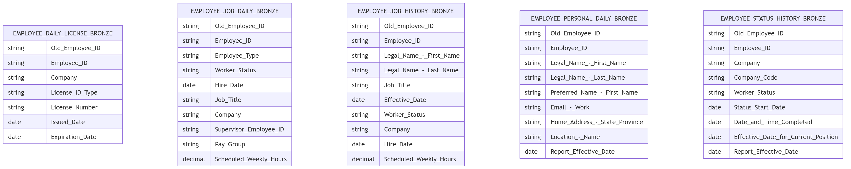

Silver
(List of table names)

Table Names:

1) dim_employee_lob_function
2) dim_employee_company
3) dim_employee_cost_center
4) dim_employee_business_unit
5) dim_employee_pay_frequency
6) dim_employee_job_code
7) dim_employee_job_location
8) dim_commission_plan
9) dim_commission_draw
10) dim_employee_home_company
11) dim_employee_status
12) dim_employee_hierarchy
13) dim_employee_personal_info
14) dim_employee_job_info
15) dim_employee

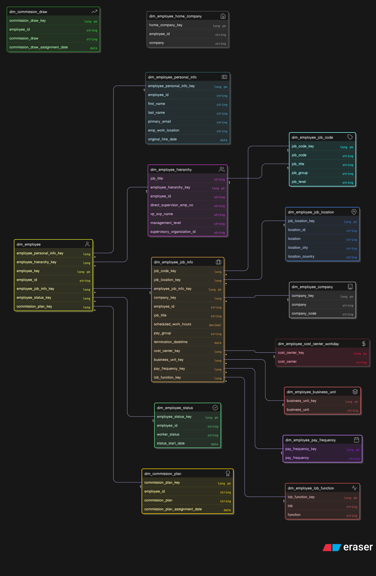

Gold
(List of table names)
Table Names :
- dim_employee
- dim_employee_hierarchy
- dim_employee_current
- Fact_employee_daily

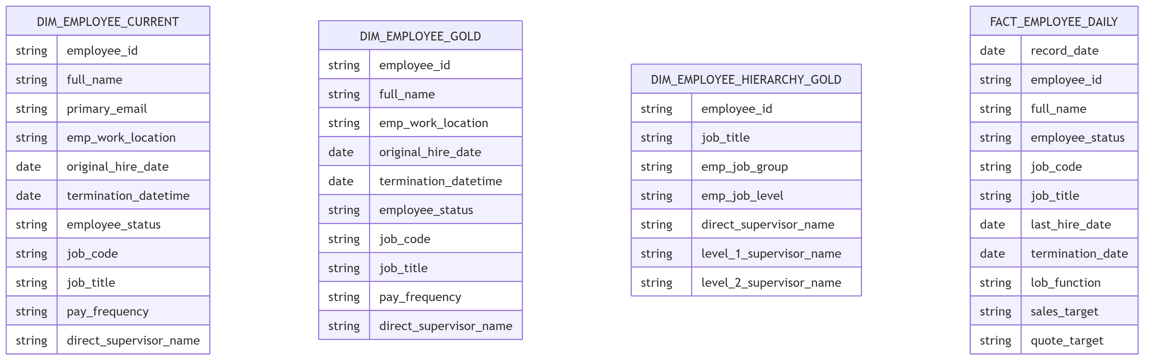

1. Bronze Layer — Lakeflow Connect Ingestion Pipelines

These are managed ingestion pipelines with no custom transformation logic.
Lakeflow Connect calls Workday RAAS endpoints and writes data directly into Bronze tables with SCD2 handling.
DAB Resource Key | Deployed Name | Connection | Destination Table | Primary Keys
employee_current_data_job_report | {env}_employee_current_data_job_report | databricks-blemployeecurrentdatajob | employee_current_data_job_report | Old_Employee_ID, Employee_ID, Employee_Type, Worker_Type, Job_Code, Worker_Status, Status_Start_Date, Business_Unit_01, LOB_-Job_Function_04, Change_Job-_Effective_Date, Report_Effective_Date
employee_current_data_personal_report | {env}_employee_current_data_personal_report | databricks-blemployeecurrentdatapersonal | employee_current_data_personal_report | Employee_ID, Languages_group, Report_Effective_Date
pipeline_employee_current_licenses_report | {env}_emp_current_licenses_report | databricks-blemployeecurrentlicences | employee_current_licenses_report | Employee_ID, Old_Employee_ID, Licenses_group
pipeline_employee_status_history_report | {env}_employee_status_history_report | databricks-employeestatushistory | employee_status_history_report | Old_Employee_ID, Employee_ID, Company, Worker_History
pipeline_employee_job_history_report | {env}_employee_job_history_report | databricks-bljobhistory | employee_job_history_report | Employee_ID, Old_Employee_ID, Worker_Status, Job_Code, Effective_Date, Business_Process_Reason_Text, Report_Effective_Date

2. Bronze Layer — DLT Notebook Pipelines

These pipelines use @dlt.table and dlt.read() decorators and represent the highest migration impact due to dependency on DLT orchestration and schema management.
DAB Resource Key | Deployed Name | Notebook | Compute | Purpose
job_info_bronze | {env}_job_info_bronze | employee_job_info_bronze.ipynb | Photon, 1–4 workers | Transforms job landing data into employee_job_daily_bronze
personal_info_bronze | {env}_personal_info_bronze | employee_personal_info_bronze.ipynb | Photon, 1–4 workers | Transforms personal landing data into employee_personal_daily_bronze
combined_info_bronze | {env}_combined_info_bronze | combined_job_file_bronze.ipynb | Photon, 1–4 workers | Joins job and personal data into combined_employee_info_bronze
license_bronze | {env}_license_bronze | employee_license_bronze.ipynb | Photon, 1–4 workers | Transforms license landing data into Bronze tables
status_history_bronze | {env}_status_history_bronze | employee_status_history_bronze.ipynb | Serverless | Transforms status history landing data into Bronze tables
job_history_bronze | {env}_job_history_bronze | employee_job_history_bronze.ipynb | Serverless | Transforms job history landing data into Bronze tables

3. Silver Layer — DLT Notebook Pipeline
DAB Resource Key | Deployed Name | Notebook | Compute | Purpose
license_silver | {env}_license_silver | employee_license_silver.ipynb | Photon, 1–4 workers | Processes license Bronze data into Silver tables

4. Silver Layer — Standard Notebook Tasks (Non-DLT)

These notebooks execute as standard notebook tasks on Databricks job clusters and are not DLT-based.
Migration impact is comparatively lower because they already follow standard task execution patterns.
Notebook | Job | Purpose | Output Tables
silver_dimensions | daily-employee-pipeline | Performs SCD2 processing for employee dimensions | dim_employee_status, dim_employee_bonus_plan, dim_employee_personal_info, dim_employee_hierarchy, dim_employee_job_info, dim_employee and lookup tables
silver_history_dimensions | history-employee-pipeline | Historical dimension processing and backfill handling | Same dimension tables in historical processing mode

5. Gold Layer — Standard Notebook Tasks (Non-DLT)
Notebook | Job | Purpose | Output Tables
hr_management_gold | Both jobs | Master Gold dimension assembly and post-processing (C058, D059) | dim_employee_hierarchy, dim_employee, dim_employee_current
fact_employee_daily | Both jobs | Generates daily employee snapshot fact table | fact_employee_daily

6. Bronze Layer — Utility Notebook
# | Notebook | Job | Purpose
1 | cleanup_tables | daily-employee-pipeline | Performs pre-run table cleanup

Lineage Diagram
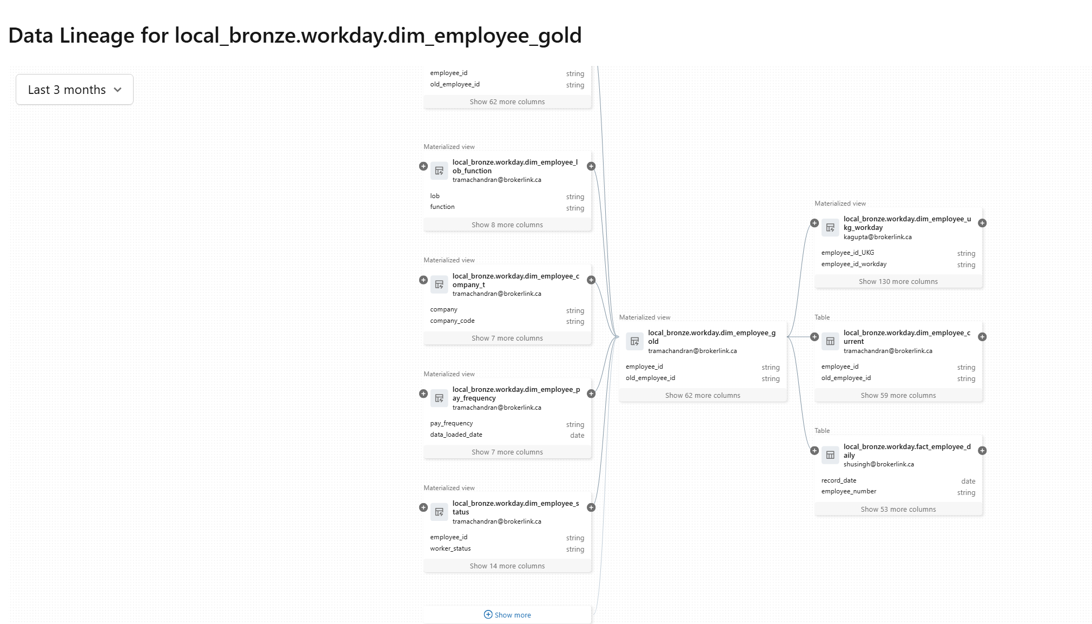

End to end Pipeline Diagram
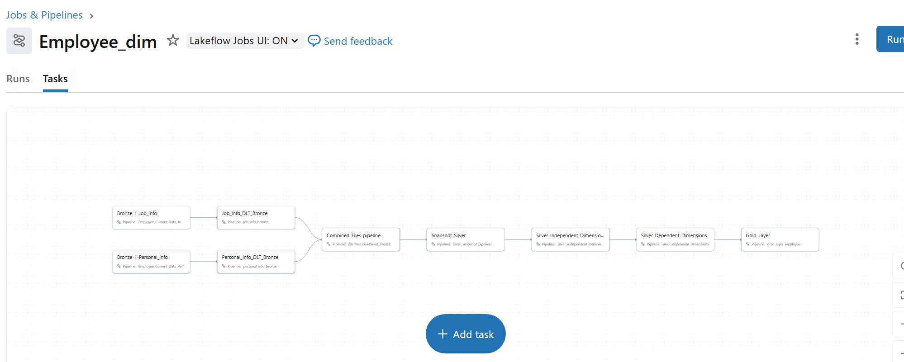

Workday Source to Target Mapping

BrokerLink_UKG-WD mapping for Databricks_v3.xlsx

Deployment Runbook

This will be documented separately once the final changes for production CICD is completed.

Notebook Pseudocode summary

Silver – Independent Dimensions

FUNCTION build_silver_independent_dimensions():

# 1) Personal Info
DIM_EMPLOYEE_PERSONAL_INFO :=
SELECT DISTINCT employee_id, first_name, last_name, primary_email, emp_work_location, original_hire_date
FROM bronze.employee_personal_daily
WHERE employee_id IS NOT NULL
AND first_name IS NOT NULL
AND last_name IS NOT NULL
DEDUPLICATE BY (employee_id) KEEP LATEST

# 2) Status
DIM_EMPLOYEE_STATUS :=
SELECT DISTINCT employee_id, worker_status, status_start_date
FROM bronze.employee_status_history
FILTER worker_status IN ('Active','Leave','Terminated')
DEDUPLICATE BY (employee_id, worker_status) KEEP LATEST

# 3) Job Code
DIM_EMPLOYEE_JOB_CODE :=
SELECT DISTINCT job_code, job_title, job_group, job_level
FROM bronze.employee_job_daily
WHERE job_code IS NOT NULL
DEDUPLICATE BY (job_code) KEEP LATEST

# 4) Job Location
DIM_EMPLOYEE_JOB_LOCATION :=
SELECT DISTINCT location_id, location, location_city, location_country
FROM bronze.employee_job_daily
WHERE location_id IS NOT NULL
DEDUPLICATE BY (location_id)

# 5) Company / Business Unit / Pay Frequency / LOB Function
DIM_EMPLOYEE_COMPANY :=
SELECT DISTINCT company, company_code FROM bronze.employee_job_daily
DIM_EMPLOYEE_BUSINESS_UNIT :=
SELECT DISTINCT business_unit FROM bronze.employee_job_daily
DIM_EMPLOYEE_PAY_FREQUENCY :=
SELECT DISTINCT pay_frequency FROM bronze.employee_job_daily
DIM_EMPLOYEE_LOB_FUNCTION :=
SELECT DISTINCT lob AS lob, function AS function FROM bronze.employee_job_daily

Silver – Dependent Dimensions (pseudocode)

FUNCTION build_silver_dependent_dimensions():
# 1) Job Info (depends on several independent dims)
DIM_EMPLOYEE_JOB_INFO :=
SELECT employee_id, job_title, scheduled_work_hours, pay_group,
LOOKUP_KEY(job_location_id -> DIM_EMPLOYEE_JOB_LOCATION) AS job_location_key,
LOOKUP_KEY(job_code -> DIM_EMPLOYEE_JOB_CODE) AS job_code_key,
LOOKUP_KEY(company -> DIM_EMPLOYEE_COMPANY) AS company_key,
LOOKUP_KEY(cost_center -> DIM_EMPLOYEE_COST_CENTER) AS cost_center_key,
LOOKUP_KEY(business_unit -> DIM_EMPLOYEE_BUSINESS_UNIT)AS business_unit_key,
LOOKUP_KEY(pay_frequency -> DIM_EMPLOYEE_PAY_FREQUENCY)AS pay_frequency_key,
LOOKUP_KEY(lob_function -> DIM_EMPLOYEE_LOB_FUNCTION) AS lob_function_key
FROM bronze.employee_job_daily
DEDUPLICATE BY (employee_id) KEEP LATEST

# 2) Hierarchy (can relate to job_code)
DIM_EMPLOYEE_HIERARCHY :=
SELECT employee_id, job_title, direct_supervisor_emp_no, vp_svp_name, management_level, supervisory_organization_id,
OPTIONAL_LOOKUP_KEY(job_code -> DIM_EMPLOYEE_JOB_CODE) AS job_code_key
FROM bronze.employee_job_daily
DEDUPLICATE BY (employee_id) KEEP LATEST

# 3) Bonus Plan (or Commission Plan)
DIM_EMPLOYEE_BONUS_PLAN :=
SELECT employee_id, bonus_plan, assignment_date
FROM bronze.employee_job_daily
WHERE bonus_plan IS NOT NULL
DEDUPLICATE BY (employee_id, bonus_plan) KEEP LATEST

# 4) Employee (hub dimension: references other dependent/independent dims via surrogate keys)
DIM_EMPLOYEE :=
SELECT
employee_id,
LOOKUP_KEY(employee_id -> DIM_EMPLOYEE_PERSONAL_INFO) AS employee_personal_info_key,
LOOKUP_KEY(employee_id -> DIM_EMPLOYEE_JOB_INFO) AS employee_job_info_key,
LOOKUP_KEY(employee_id -> DIM_EMPLOYEE_STATUS) AS employee_status_key,
LOOKUP_KEY(employee_id -> DIM_EMPLOYEE_HIERARCHY) AS employee_hierarchy_key,
OPTIONAL_LOOKUP_KEY(employee_id -> DIM_EMPLOYEE_BONUS_PLAN) AS bonus_plan_key
FROM (
SELECT DISTINCT employee_id FROM bronze.employee_job_daily
)

RETURN all dependent dims

Gold: DIM_EMPLOYEE_GOLD (pseudocode)
FUNCTION build_dim_employee_gold():

SRC := read(silver.dim_employee_current) # curated employee snapshot
DIM_EMPLOYEE_GOLD :=
SELECT employee_id, full_name, primary_email, emp_work_location, job_code, job_title, employee_status, original_hire_date, termination_datetime, direct_supervisor_name
FROM SRC
DEDUPLICATE BY (employee_id) KEEP LATEST
WRITE DIM_EMPLOYEE_GOLD

Gold: FACT_EMPLOYEE_DAILY_GOLD (pseudocode)
FUNCTION build_fact_employee_daily_gold():
SRC := read(silver.fact_employee_daily)
FACT_EMPLOYEE_DAILY_GOLD :=
SELECT record_date, employee_id, full_name, employee_status, job_code, job_title,
last_hire_date, termination_date, lob_function, quote_target, sales_target
FROM SRC
FILTER record_date IS NOT NULL
WRITE FACT_EMPLOYEE_DAILY_GOLD

Workday Lakeflow Connector Steps
1) In Databricks, under Job & Pipelines, click on Create new Ingestion Pipeline
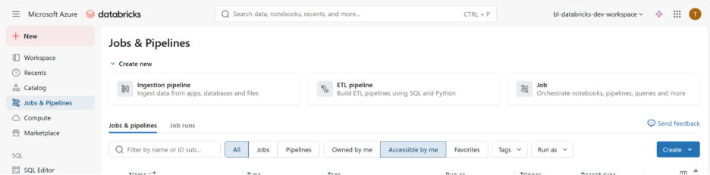
2) Select Workday Reports under Databricks Connector
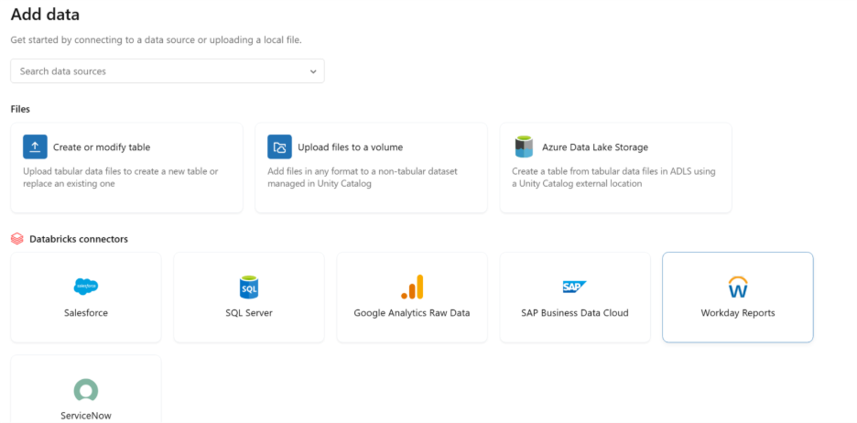
3) Enter the appropriate connection details for the corresponding Report (assuming
the connection is already created for each report and given access to required
users)
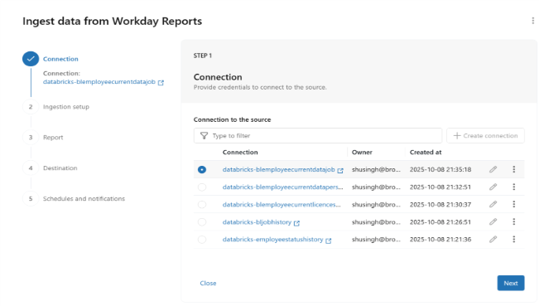
4) Enter Catalog and Schema details and give an appropriate pipeline name
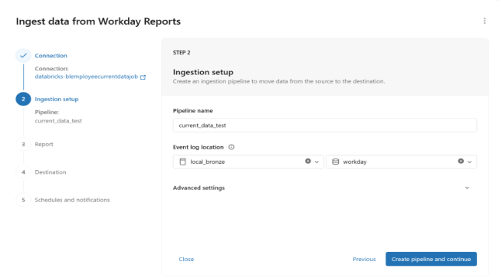
5) Enter corresponding Workday report URL (matching the connection) and enter the
‘+’ icon.
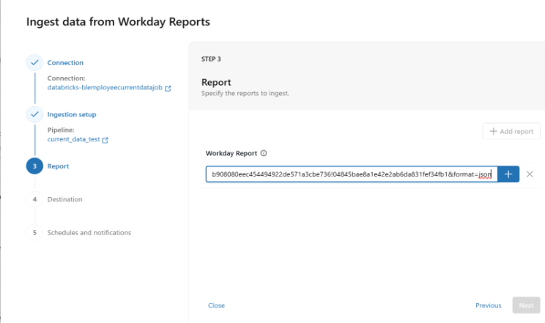
6) Now, choose the required details – target table name, primary key columns (make
sure to give the right set of keys for primary as if source has duplicates for your given
keys – it will fail), columns to include and option to Enable/Disable history tracking.
Once done with this, go next
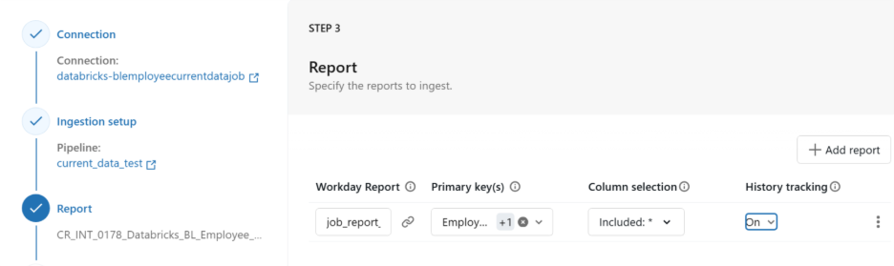
7) Click Save and Continue and proceed to next step.
8) You can optionally choose schedules/ triggers and enable/disable email notification
(in case job fails)
9) Give “Save and run pipeline” and you will start seeing the pipeline start to ingest
data from the Workday report.

Testing Considerations

4.1 Testing Objectives

The primary objective of testing for the BrokerLink Workday-to-Databricks integration project is to ensure that all Workday RaaS datasets ingested into the Databricks Lakehouse (Bronze, Silver, Gold layers) are accurate, complete, and transformed correctly to support downstream PowerBI and SSRS reporting.
Testing validates that Workday data is:
- Extracted correctly through Lakeflow Connect
- Transformed accurately through DLT (Delta Live Tables) and Databricks notebooks
- Loaded into the Databricks Lakehouse in a reliable, consistent format
- Correctly reflected in all downstream HR reporting and analytics
The objective is to ensure that data loaded from Workday into Databricks—after all business transformations—is accurate, consistent, and matches expectations in PowerBI reports and SSRS datasets.
Key Testing Objectives
- Data Accuracy: Validate that Workday data is extracted from RaaS endpoints, transformed via DLT pipelines, and loaded into Bronze/Silver/Gold tables correctly.
- Data Completeness: Ensure all expected Workday records are ingested—daily runs and historical loads—without omissions.
- Data Consistency: Confirm transformations, mapping logic (~200 mapped fields), hierarchy rules, and SCD2 processing are applied as designed.
- Performance: Validate the efficiency and reliability of Lakeflow ingestion, DLT pipelines, and execution SLAs.
- Data Integrity: Verify schema conformance, effective dating logic, referential integrity, and business rule validation.

4.2 Scope of Testing:

Testing applies across all layers of the Databricks Lakehouse:
Bronze Layer – Raw Workday RaaS Ingestion
- Validate ingestion via Lakeflow Connect
- Basic checks for completeness, schema alignment, and raw data fidelity
- Validate ingestion of daily and historical RaaS files
- Confirm that Workday extract metadata (timestamps, run IDs) is captured correctly
Silver Layer – Standardized, Cleaned, and SCD2 Modeled Data
- Validate DLT transformation logic
- Validate dimension creation (LOB, Company, Business Unit, Cost Center, Status, Job, Pay Frequency, etc.)
- Validate cleansing, defaulting, metadata fields, and SCD2 logic
- Confirm record-level accuracy and effective date behavior
Gold Layer – Curated HR Facts and Dimensional Models
- Validate gold layer datasets consumed by SSRS and PowerBI
- Confirm business-ready logic (hierarchy, employee master, combined UKG–Workday model, current employee view)
Additional Scope:
- Workday RaaS report tables
- Historical snapshots (Job Historical, Status Historical)
- Visual Lease mapping validations (for location mapping)

4.3 Testing Approach and Methodology:

The project follows an Agile testing methodology, aligned with iterative Databricks development sprints.
Key principles include:
- Continuous testing integrated throughout pipeline development
- Early detection of data defects using incremental validation
- Collaboration between Genpact, BL Analytics, HRMS, and App Dev teams
- Iterative refinement of logic based on real Workday test tenant data
- Frequent validation cycles for downstream PowerBI impacts
Testing occurs iteratively across ingestion, transformation, and reporting components.

4.4 Testing Techniques and Tools:

Testing incorporates multiple techniques to ensure high-quality HR datasets:
Techniques
- Unit testing for pipeline logic and utility functions
- Integration testing of Lakeflow → Bronze → Silver → Gold flows
- System testing for end-to-end processing
- Regression testing for PowerBI and SSRS dependencies
- Exploratory data validation using SQL and notebooks
- Data quality testing (row counts, schema drift, null checks, effective dating)
- Acceptance testing with BL & HR stakeholders
Tools
- Databricks SQL / Notebooks for data validation
- Excel-based test scripts and mapping documents
- JIRA can be used for defect management.

4.5 Risks and Mitigation Strategies:

Common risks in Workday-to-Databricks ETL projects include:
Risk | Impact | Mitigation
Missing or inconsistent Workday fields | Incorrect reporting | Early review of mapping workbook and sample RaaS extracts
Schema drift in Workday reports | Pipeline failures | Automated schema validation & DLT expectations
Historical data anomalies | Incorrect trends in BI | Historical reconciliation + anomaly checks
Late delivery of RaaS endpoints | Development delays | Align sprint plan with HRMS timelines

Risk owners and response plans should be documented in the risk register.

4.6 Exit Criteria:

Testing will be considered complete when all of the following conditions are met:
- Requirements Coverage: 100% of mapped fields and pipeline requirements are validated through test cases.
- Defect Resolution: All critical and high-priority defects are resolved, retested, and closed.
- Test Coverage: At least 95% test execution coverage achieved for pipeline logic and reporting checks.
- Execution Completion: All planned test cases (unit, integration, system, regression) executed successfully.
- Regression Testing: Verify that the new Workday-based pipelines have not introduced defects or negatively impacted the datasets consumed by downstream applications. The guideline is to use Workday data as the baseline for validation; comparisons with UKG data should not be used as regression criteria because Workday data is structured to align with Oracle Finance systems, making one-to-one comparisons with UKG inaccurate.
- Data Validation: Upstream-to-downstream data flow validated across Bronze, Silver, and Gold layers.
- Documentation: Test summary report, validation logs, lineage checks, and reconciliation results documented and reviewed.
- Stakeholder Approval: "Go/No-Go" decision obtained from HRMS, Analytics, App Dev, and Project Leadership.

4.7 Test cases:
Bronze
Silver
Gold – WIP

Expected Project Results
Bronze - Bronze Layer Testresult.zip
Silver – Silver Layer_Test Result_9th Dec.zip
Gold - wip

Measures of Success

Data Quality & Integrity Measures

- Accuracy/Validation Rate: The percentage of data that is correctly transformed and loaded according to predefined business rules and validation checks.
- Completeness: Ensures all expected data records from the source are present in the target system without any omissions. This is often measured by comparing row counts between source and target systems.
- Consistency: Verifies that data remains consistent across different systems and stages of the pipeline, with no conflicts in values for the same data point.
- Error Rate: The percentage of failed rows or records due to invalid data, logical errors, or format mismatches. A low error rate is a key indicator of a healthy pipeline.
- Freshness: Measures how up to date the data is, often tracked using timestamps to confirm the recency of updates. This ensures that analysis is based on current information.

Operational Reliability Measures

- Pipeline Success Rate: The percentage of jobs that complete successfully without failure. A high success rate (e.g., >99.5%) indicates a stable pipeline.
- Mean Time to Recovery (MTTR): The average time it takes to fix a failed pipeline and resume normal operations. A shorter MTTR indicates efficient error handling and incident response procedures.
- Uptime/Availability: The total time the ETL pipeline is operational and available for processing data, typically measured as a percentage (e.g., 99.9% uptime).
- SLA Compliance: Adherence to agreed-upon Service Level Agreements (SLAs) regarding data delivery times and quality standards, which can have direct business impact and regulatory implications.
- Mean Time Between Failures (MTBF): The average time a pipeline operates without an incident, indicating its overall robustness and stability.

Approvals

Solution Document Sign-Off

Date | Version | Role | Name | Source

Appendix A: Impact Areas

Areas of Impact | Impact Y/N | Owner | Project Contact

*Notes:

Appendix B: References

